**CCT College Dublin**

**Assessment Cover Page**

|  |  |
| --- | --- |
| **Module Title:** | Client-Side Programming |
| **Assessment Title:** | CA1 |
| **Lecturer Name:** | Sam Weiss |
| **Student Full Name:** | Bárbara Candido de Souza |
| **Student Number:** | 2023059 |
| **Assessment Due Date:** | Sunday 31st March 2024 |
| **Date of Submission:** | Sunday 31st March 2024 |

**Declaration**

|  |
| --- |
| By submitting this assessment, I confirm that I have read the CCT policy on Academic Misconduct and understand the implications of submitting work that is not my own or does not appropriately reference material taken from a third party or other source. I declare it to be my own work and that all material from third parties has been appropriately referenced. I further confirm that this work has not previously been submitted for assessment by myself or someone else in CCT College Dublin or any other higher education institution. |

# **Report**

Outlining the fundamentals of client-side programming for adding dynamic content this website.

## HTML

I’ve implemented a skeleton across all pages to ensure consistent structure and layout for organized content. This includes a header, navigation menu, the main content, sections dividing the other contents and the footer (MDN, 2023).

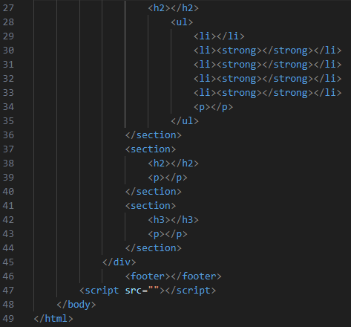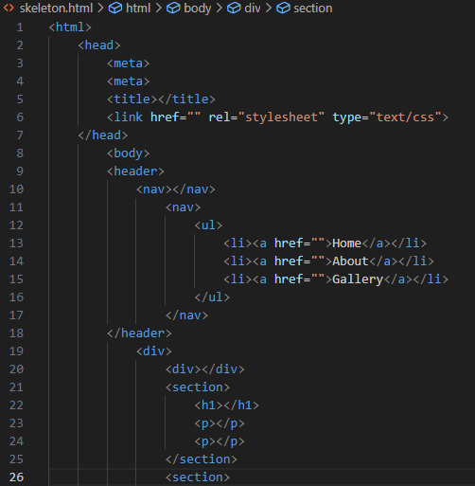

Figure 1 Structure on HTML

Figure 2 Structure on HTML

## CSS

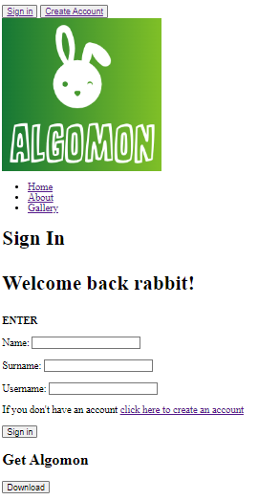In complement to the HTML structure, CSS styling has been applied to create an intuitive interface, facilitating user access and content consumption with a straightforward layout (W3School, 2024).

Adjustments such as font size and color, headings, spacing between content helps for a better visualization to the end user. The external CSS file applied to all pages ensures a consistency across all the website. (QuickRef.ME, 2024).

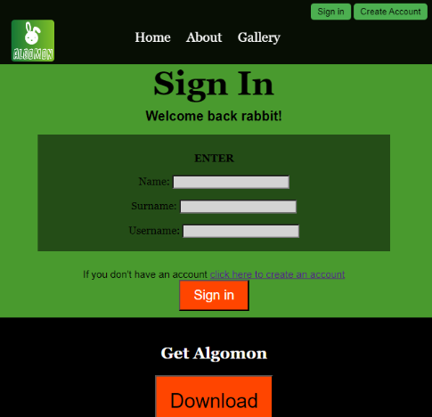

Figure 5 HTML with CSS

Figure 6 HTML with CSS

Figure 7 HTML without CSS

Figure 8 HTML without CSS

### Examples off the CSS used in this website

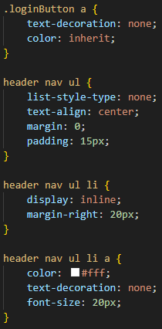Site Navigation

Figure 9 Navigation Bar

Figure 10 Navigation bar CSS

For a more familiar feeling from the users, this website also tries to follow a certain standard. So that everyone knows how to use the website and don’t feel lost while navigating. That also can be called the Jakob’s Law of the Internet User Experience (Nielsen, 1999). Combining HTML, CSS and JavaScript the website gives the user a more comfortable feeling, making them stay longer to check more content.

The user can easily access all pages in the navigation bar. It contains 5 pages on the website: Home, About and Gallery located in the center and a Sign In and Create Account as buttons positioned in the right corner. Additionally, clicking the logo redirects users to the Home Page (dragosct, 2018).

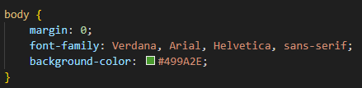Fonts

Commonly used website fonts have been selected to enhance readability and convey clarity, contributing to visual consistency (Davidov, 2022).

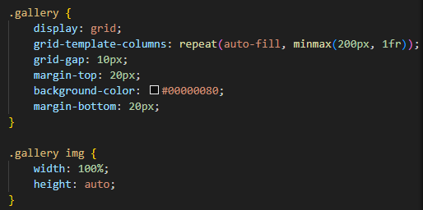

Grid display for the gallery

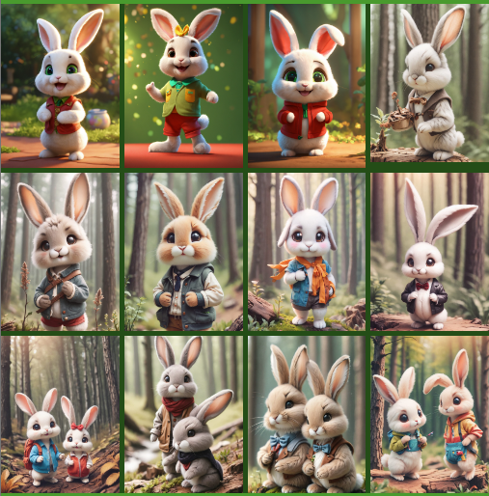 A grid layout has been implemented for the gallery, offering an optimized visualization of images that dynamically adjusts based on the page size (Maheshwari, 2021).

Figure 12 Grid on CSS

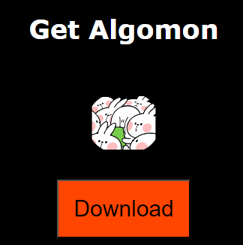Buttons

Figure 14 Button in the Website

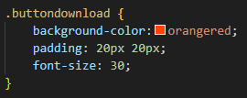 Flashy buttons have been incorporated to attract user attention and encourage interaction.

Figure 15 Grid in the website

Figure 13 Button on CSS

## JavaScript - Event listeners

The JavaScript adds interactivity and more dynamic website enhancing the user experience. (SheCodes, 2023)

### Event Listener 1 – Mouseover and Mouseout

This is actually two Event Listeners, the **mouseover** and the **mouseout**. The user interacts with the navbar, on the three main pages and the other two pages placed as buttons in the corner.

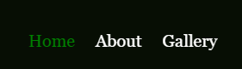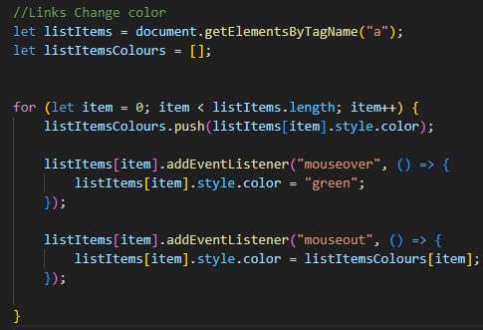









Figure 16 Event Listener 1 Code - Mouseover and Mouseout

Figure 17 Event Listener 1 Code - Mouseover and Mouseout

Figure 18 Event Listener 1 on website - Mouseover and Mouseout

Figure 19 Event Listener 1 on website - Mouseover and Mouseout

### Event Listener 2 – Scroll

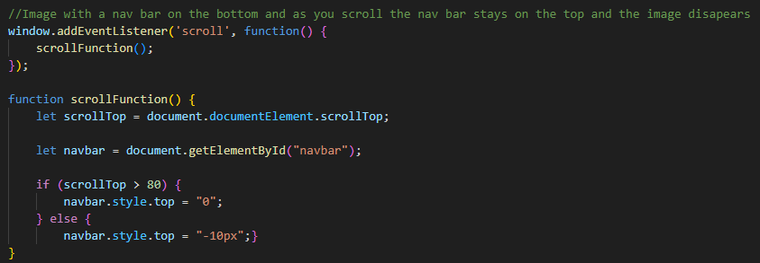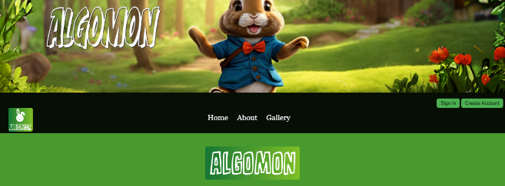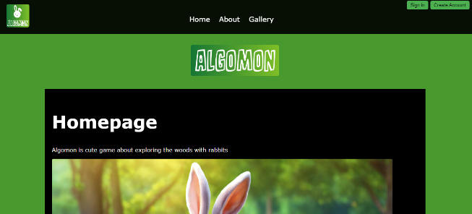I wanted a different homepage display in the beginning where the navbar stays after the image and as you **scroll** down the image disappears and the navigation bar stays at the top. For that effect I could use an *Event Listener* on JavaScript to differentiate the main page from the other pages.

Figure 20 Event Listener 2 code - Scroll

Figure 21 Event Listener 2 on website - Scroll

Figure 22 Event Listener 2 on website - Scroll

### Event Listener 3 – Click

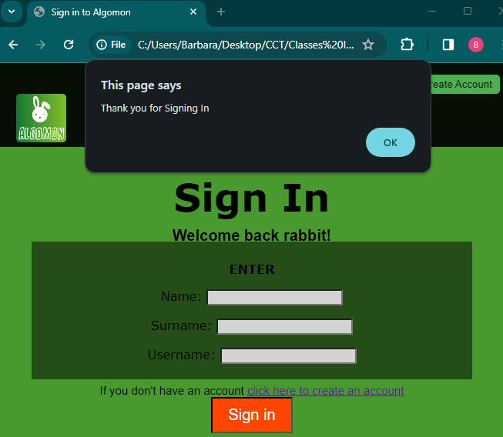A simple event listener that after the user **click** the button of Sign in or Download gets a message in JavaScript. (W3Schools, 2023)

Figure 23 Event Listener 3 on the website - Click

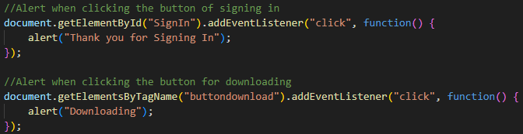

Figure 24 Event Listener 3 Code- Click

# References

Davidov, S. (2022). *40 Best Fonts for Websites (Free and Paid)*. Elementor Blog. Available at: https://elementor.com/blog/web-fonts/?utm_source=google&utm_medium=cpc&utm_campaign=11138809851&utm_term=&gad_source=1&gclid=Cj0KCQjwk6SwBhDPARIsAJ59GwdHTHyfwBHhJHLLa4_heu4LtZggNwCZyCPwhD67NzrXDBUb4IjBzXAaAoP4EALw_wcB

dragosct. (2018). *Add image logo to navbar*. Github. Available at: https://github.com/creativetimofficial/material-kit/issues/107

Maheshwari, Y. (2021). *HTML and CSS gallery grid design*. Stack Overflow. Available at: https://stackoverflow.com/a/67546434/23789379

MDN. (2023). *Introduction to HTML*. MDN. Available at: https://developer.mozilla.org/en-US/docs/Learn/HTML/Introduction_to_HTML

Nielsen, J. (1999). *Jakob's Law of Internet User Experience*. NNGroup. Available at: https://www.nngroup.com/videos/jakobs-law-internet-ux/

QuickRef.ME. (2024). *CSS 3*. QuickRef.ME. Available at: https://quickref.me/css3#css-getting-started

SheCodes. (2023). *[JavaScript] - How to add an event listener in JavaScript*. SheCodes. Available at: https://www.shecodes.io/athena/45488-how-to-add-an-event-listener-in-javascript#:~:text=To%20add%20an%20event%20listener%20in%20JavaScript%2C%20you%20need%20to,run%20when%20the%20event%20occurs.&text=const%20button%20%3D%20document.,('myButton')%3B%20butt

W3School. (2024). *CSS Introduction*. W3School. Available at: https://www.w3schools.com/css/css_intro.asp

W3Schools. (2023). *JavaScript HTML DOM EventListener*. W3Schools. Available at: https://www.w3schools.com/js/js_htmldom_eventlistener.asp

# Table of Figures

Figure 1 Structure on HTML 2

Figure 2 Structure on HTML 2

Figure 3 CSS Code 2

Figure 4 CSS Code 2

Figure 5 HTML with CSS 2

Figure 6 HTML with CSS 2

Figure 7 HTML without CSS 2

Figure 8 HTML without CSS 2

Figure 9 Navigation Bar 3

Figure 10 Navigation bar CSS 3

Figure 11 Fonts on CSS 3

Figure 12 Grid on CSS 3

Figure 14 Button in the Website 3

Figure 13 Button on CSS 3

Figure 15 Grid in the website 3

Figure 16 Event Listener 1 Code - Mouseover and Mouseout 4

Figure 17 Event Listener 1 Code - Mouseover and Mouseout 4

Figure 18 Event Listener 1 on website - Mouseover and Mouseout 4

Figure 19 Event Listener 1 on website - Mouseover and Mouseout 4

Figure 20 Event Listener 2 code - Scroll 4

Figure 21 Event Listener 2 on website - Scroll 4

Figure 22 Event Listener 2 on website - Scroll 4

Figure 23 Event Listener 3 on the website - Click 4

Figure 24 Event Listener 3 Code- Click 4